YOU ARE INVITED!

You are invited to attend the GLENORA AUTOMOBILE SHOW. This will be held at the Glenora District High School at Bushy Park on SUNDAY NOVEMBER 24 11:00AM – 3:00PM. CAR REGISTRATION IS between 10:00am-10:30am. A unique day in a beautiful setting not to be missed!

Funds from this event will be supporting students at Glenora District High School with part proceeds being donated to Men’s Shed and Prostate Australia.

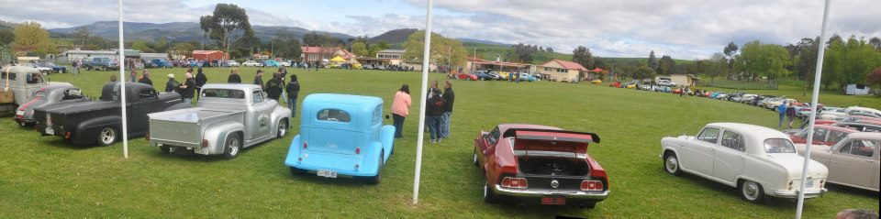

All cars and motorcycles entering are welcome AT NO COST, including passengers. The following categories will be open for entry at the show and there will be some great prizes/trophies up for grabs.

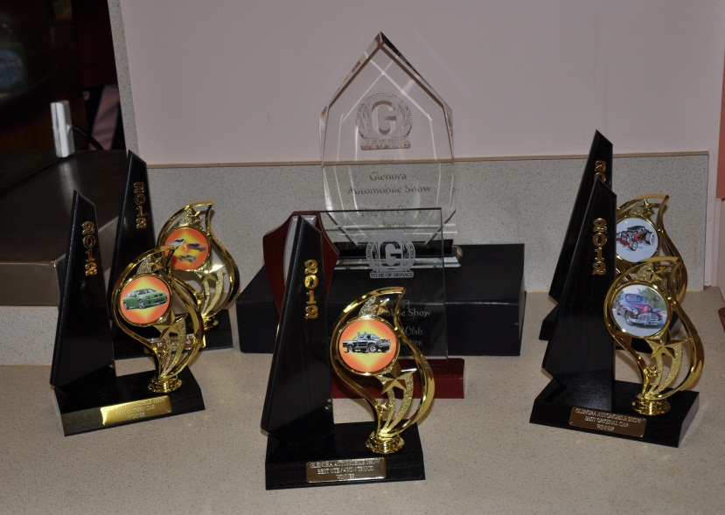
CATEGORIES
Original up to 1949
Hot Rod
Best Ute/4WD/Truck
Modern Era (Post 1982)
People’s Choice
Classic Up to 1982
*New Category This Year*
Motorcycle

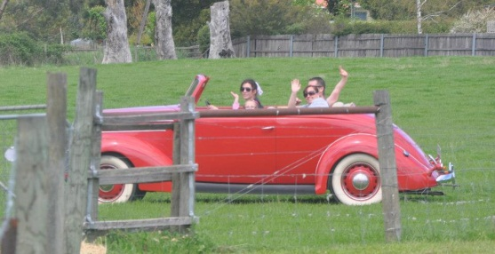
There will be PLENTY for all with their cars on display to do.

This includes;

- Arts, crafts, general and car product/trade stalls
- A Car boot sale/ Swap meet
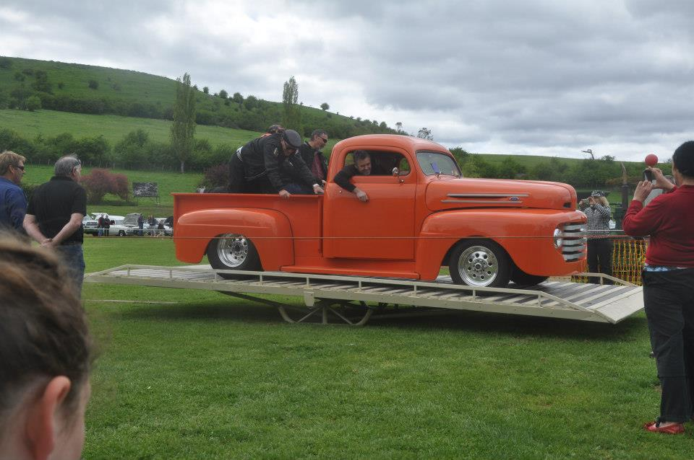
- Novelty Events for the children (and adults) e.g. Egg throwing, gumboot throw, three legged race and for entrants is the CAR BALANCING COMPETITION (How long would it take you to balance your car on a seesaw that is 20cm off the ground?)

- MUCH IMPROVED FOOD & DRINK FACILITIES (BBQ’S, HOT SPUDS AND MORE)
- Free Roadster Ride ticket on entry for a ride in a 1937 Ford Roadster.
- REAL Coffee from a coffee van available
- Plenty of seating and space

SWAPMEET
If anyone in your car club would like to book a position in the Swap meet please contact Kolby Waddilove on 0466497431. Swap meet sites this year are free and we encourage you to spread the word so it can be bigger and better!

REGISTRATION
Pre-day registration is encouraged; however on the day entry is fine 10:00-10:30am.

To register before the day, simply fill out the registration form attached and post to

Kolby Waddilove
1 Crosby Court, Rosetta,
Tasmania, 7010

Or scan and email to Kolby.waddilove@education.tas.gov.au

Alternatively you may send a text message to 0466497431 including name, car details and category you wish to be entered in.

Please let friends and family know about GAS and encourage them to come and have a look.

Come out and support the students at Glenora. Make a day of it with Mum, Dad and all the family. Plenty to eat, plenty of seating, real coffee available, lots to do. Come and try to win the Car Balance Competition or one of the category prizes. A unique day in a beautiful setting not to be missed.

Thankyou

Kolby Waddilove
Grade 10 Co-ordinator and Mathematics Teacher
Glenora District High School
620 Gordon River rd, Bushy Park, Tasmania 7140
0466497431 or 62861301

